‘Helping Researchers in Need’ for 40 years

MRBA Fundraising Week
W h o w e h a v e h e l p e d

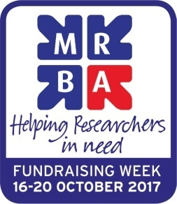

Diana’s Story

“I was so impressed with the backup service I received from the MRBA.”

Single mother ‘Diana’s work dried up after 15 years in the industry. She struggled with several low paid jobs and got into debt. Her financial worries lead to a breakdown, so she was signed off work and had to declare bankruptcy. Our help and support gave her time to get back on her feet.

Mary’s story

“The help I received from the MRBA was honestly, just terrific.”

Divorced and living alone, ‘Mary’ retired after 20 years working in market research. Suffering from osteoarthritis, mobility became a serious issue. We worked with her ex-husband’s RAF charity to finance a walk in shower to make her life easier.

Susan’s story

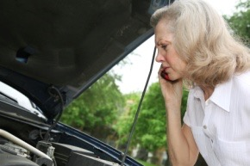
“Thank you from the family and for enabling me to get back to work.”

Susan had enormous problems including a husband unable to work due to an injury, a son profoundly deaf with little hope of getting a job, and issues with her own health. We gave her considerable support and money to buy a car so that she could return to work.
Trevor’s story
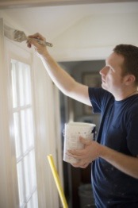
“Everyone at the MRBA has been very kind and helpful.”
‘Trevor’ has worked in the industry since university. But in his mid 40s he developed leukemia. The treatments made him so unwell he wasn’t able to work. Trevor used his savings to get by. But then his housing association flat developed a leak causing an insect infestation that took the authorities ages to fix. We helped pay off his credit card, funded an evening class to get him out, and gave him money to replace his sofa and carpets.
Ben’s story

‘Ben’s’ wife was suffering from cancer. He gave up work to nurse her, so we helped cover a few debts by paying off his credit card and covering some utility bills.

Sari’s story

“...Thank you for all of the help the MRBA gave us both emotionally and physically in our recent loss...we are now out of the red and starting to get our life back together again...”
‘Sari’ lost her daughter in a tragic accident and needed time off work during this traumatic time to support her family but she ran into debt. We helped her financially until she could go back to work.

Jason’s story
“With the MRBA’s help, I’m now able to enjoy my retirement a bit more.”
An interviewer for over 10 years, Jason loved his work. Nearing retirement he found it harder to do his job and was diagnosed with depression. With our assistance, Jason was able to clear more of his debts before retiring.
Ruth’s story
“Thank you for the cheque which went immediately to the undertakers…I will never forget you coming to my aid when I was desperate and needed some help and kindness. Thank you all.”

Suzi’s story
“For the first time in months my bank balance is showing I am in the black. You have made me feel so much better… Thank you from the bottom of my heart.”
With a very ill son, ‘Suzi’s’ own mental health has affected her because she was also very stressed about her finances. We gave her money to clear some of her debts.

All of these stories are real cases MRBA has handled, but the names of the applicants have been changed to protect their anonymity.
August 2017

