Insert your logo here
We’re supporting 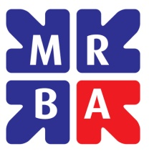
MRBA F U N D R A I S I N G W E E K
16 – 20 October 2017

To raise awareness of its great work and to help ‘Researchers in Need’

Insert your event details here

