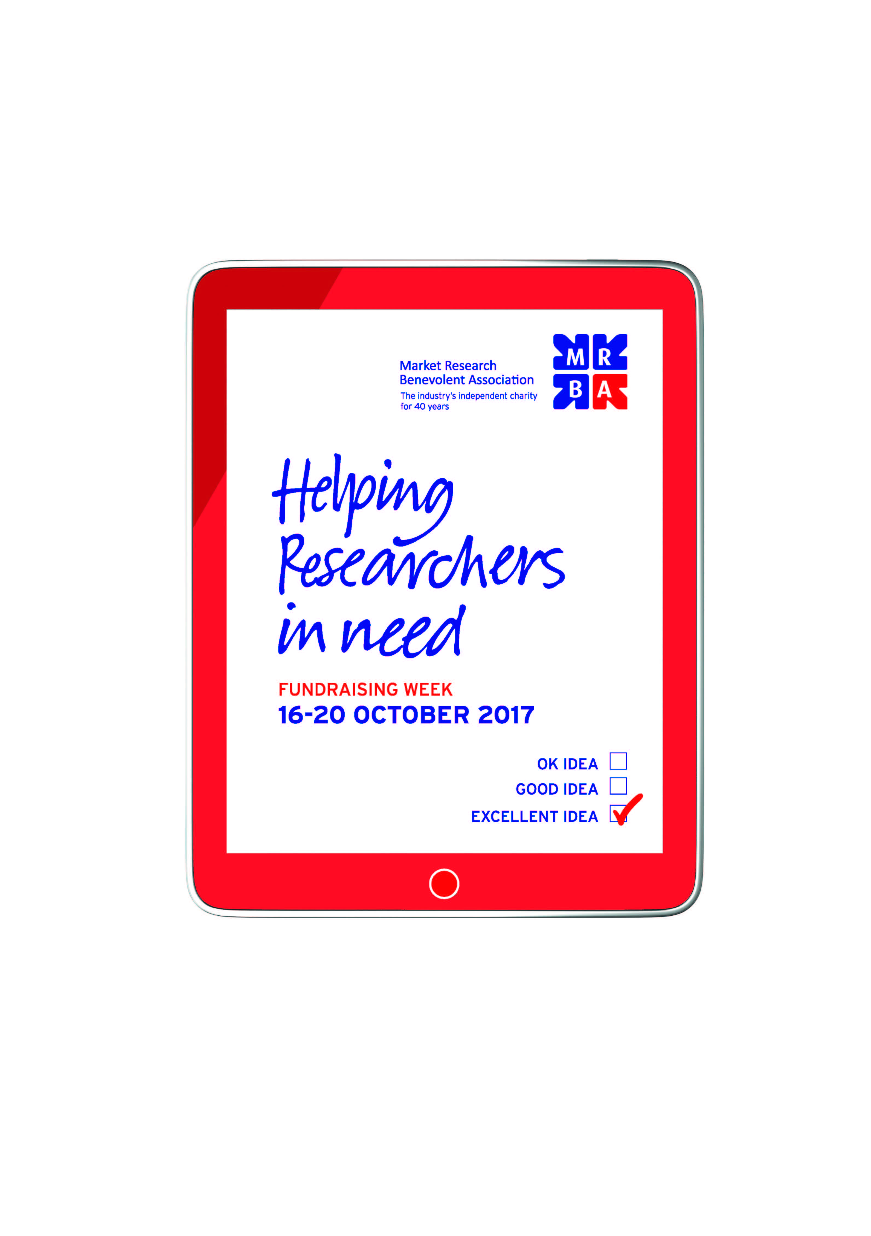
Here are some great fundraising ideas from the MRBA Week team and supporters, with particular thanks to the MRBA Champions who contributed ideas at our Champions evening on 21 June, 2017 and presented some of their successful efforts in 2015
EVENTS IN THE OFFICE

- Organise a different event for each day during the Fundraising Week - gives lots of opportunities for everyone to get involved (Network Research last time)

- Host a breakfast / coffee morning / pot luck lunch and sell cakes, drinks, bacon rolls etc. (Many Champions last time)

- A ‘Bake off’ event, selling slices of cakes and pastries that people have made (Many Champions last time)

- Run a cocktail evening and charge admission (Kudos did something similar last time)

- Host a clothes sale – get people to donate clothes and sell them

- Host a book/CD/vinyl sale - get people to donate books/CDs/vinyl and sell them

- Host a Swaparama – where you pay £X admission for the opportunity to swap up to 5 items of second hand designer clothes, gadgets etc. with others

- Organise a raffle, or Tombola or lucky dip (many Champions last time)

- Host a fancy dress competition (Kudos last time)

- Host a themed film night with paid admission (Kudos last time)

KEEPING FIT 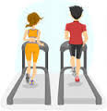

- MRBA walk to work week (perhaps donating tube/train/bus fares each day)

- Challenge staff to contribute to a target such as one million steps achieved in the week - can be done individually, by groups in lunch hour or after work, perhaps providing step counters or advising on apps to use, provide an Excel spreadsheet giving everyone’s tally per day to ‘encourage’ (Cobalt Sky last time)

- Ditch the lift - or pay to use the lift

- Ask people to put the money they would spend on sweets / snacks / coffee during MRBA Week into a jar

- Fines for swearing - or for eating chocolates or crisps or fizzy drinks at your desk

- One for the truly athletic - The MRBA Run: the Forest to Forest Run (a trek on foot from Epping Forest across London to the New Forest, roughly 100 miles); get your team to walk 1million steps during the week; or cycle X number of miles in a week

FOR THE COMPETITIVE SPIRITS

- Setup some inter-departmental competitions

- a Snail Race with staff choosing their own snail (QuadOps last year)

- a sponsored ‘lie in’ -as a John and Yoko tribute (QuadOps last time)

- Host a quiz night, bingo or race night

- Organise some traditional competitions like guess the weight of a cake, or number of M&Ms in a jar

- Hold a karaoke or talent night with paid entry

- Host a wine tasting and have a quiz led by a wine expert

- Organise a sponsored walk/run/cycle/swim event

- Set up a Poker Tournament between market research agencies, with each company contributing a team (this is an idea contributed by Network Research and anyone interested in taking part should contact suerobson@blyth.me who will put them in touch with the Network Research MRBA Champion

- Organise a London based Treasure Hunt for market research agencies to compete against one another
OFFICE MANNERS (OR NOT?)

- Charge for doing a coffee run each morning

- Charge for doing the office’s/department’s/ team’s photocopying for the week

- Fines for wearing jeans or other non-traditional office wear

- Be (Mr) BA for the Day (BA Barracus from The A Team/Snickers adverts)

- Sponsor / charge people to wear pyjamas or alternative outfit to the office for a day

It DOESN’T HAVE TO BE COMPLETED IN OCTOBER

- Create a card or online banner ad for a charity Christmas card and give a donation to the MRBA instead

- Have a charity bucket PERMANENTLY on reception so all visitors can learn about the MRBA and can donate

FINALLY - EASY WINS

- Buy and then re-sell lollipops or other goodies around the office

- Have a charity bucket on reception so all visitors can learn about the MRBA and can donate

- Add 1% to the fees you charge for all Interviewers/Recruiters during MRBA week and donate the money to MRBA

REMEMBER THESE ARE ONLY SUGGESTIONS - AND IF YOU HAVE MORE IDEAS PLEASE LET US KNOW AND WE WILL ADD THEM TO THE LIST.

GOOD LUCK AND HAVE A GREAT FUN DURING WEEK!

If you need any more information, or help, please get in touch by emailing: info@mrba.org.uk

